Emily Frazin

Overview:

This application is a way to organize the running of a dance studio.  Everything is available online for the owner, instructors, and students. Having everything available online gets rid of the paper trail of registration forms, newsletters, events/performance letters, and also makes payment of tuition easier. Dancers can create a profile that keeps track of payments and their class schedules, so they won’t forget those important details.

Goals:

My hope is that this application will cut out the stress of keeping track of all the students at a studio. All news, events, classes, and student information will be available online.

Design Layout:

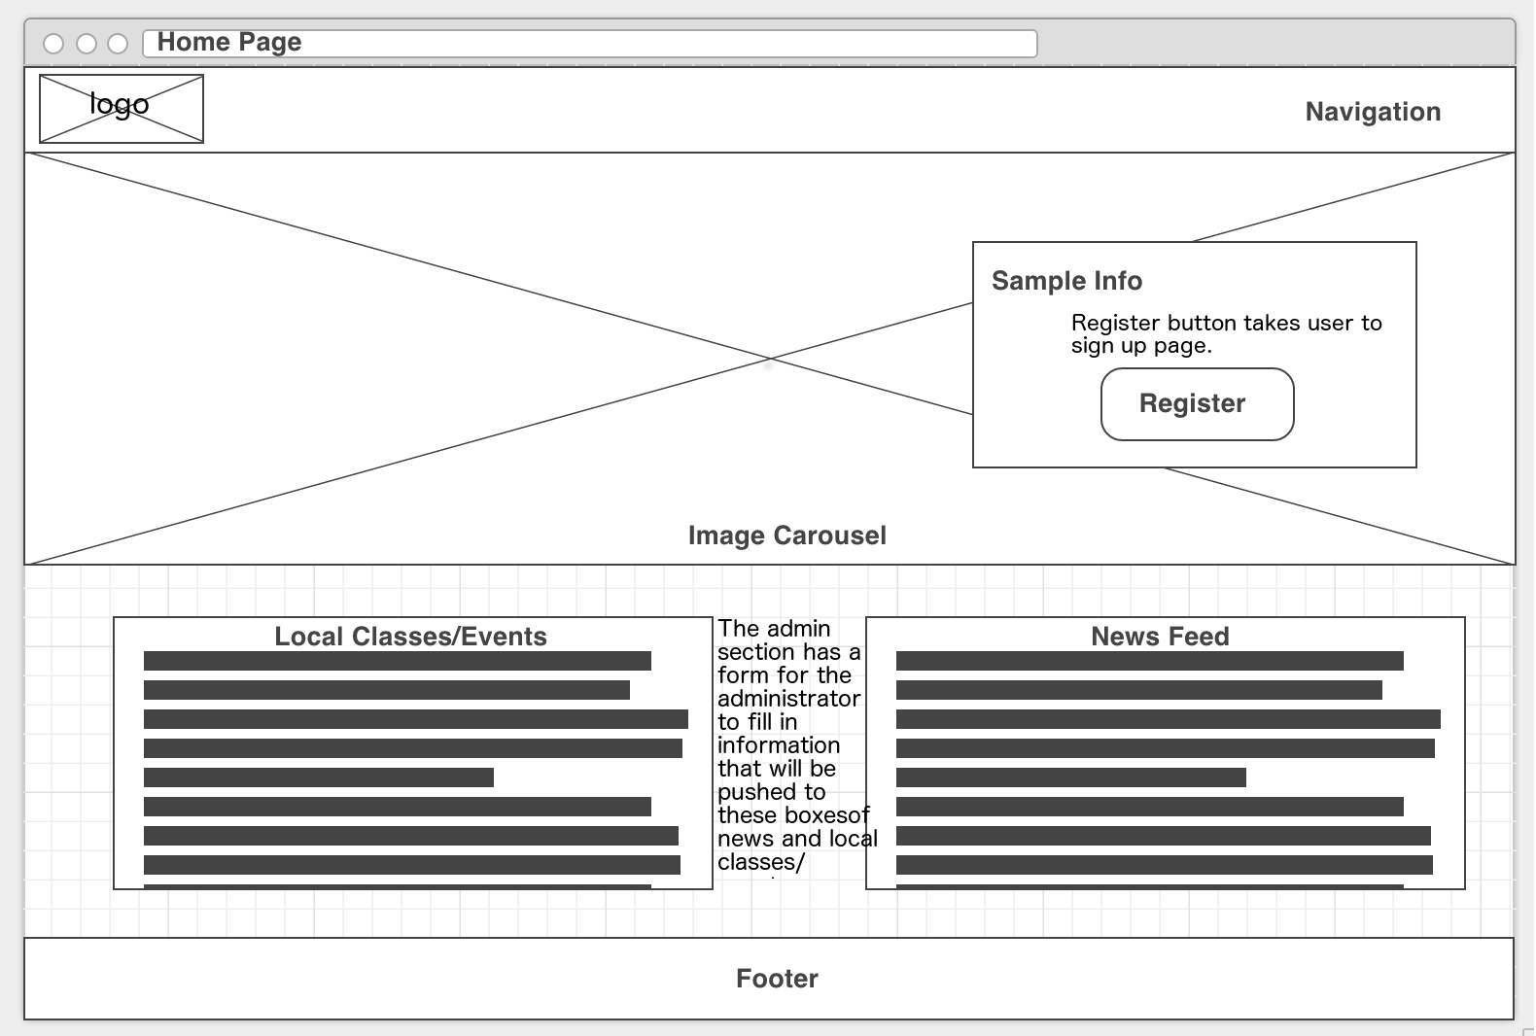

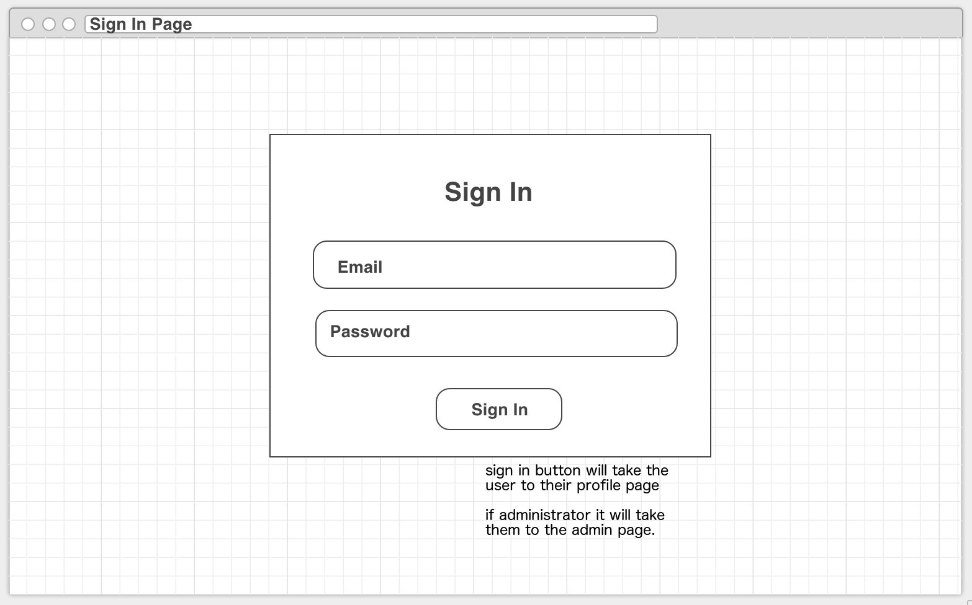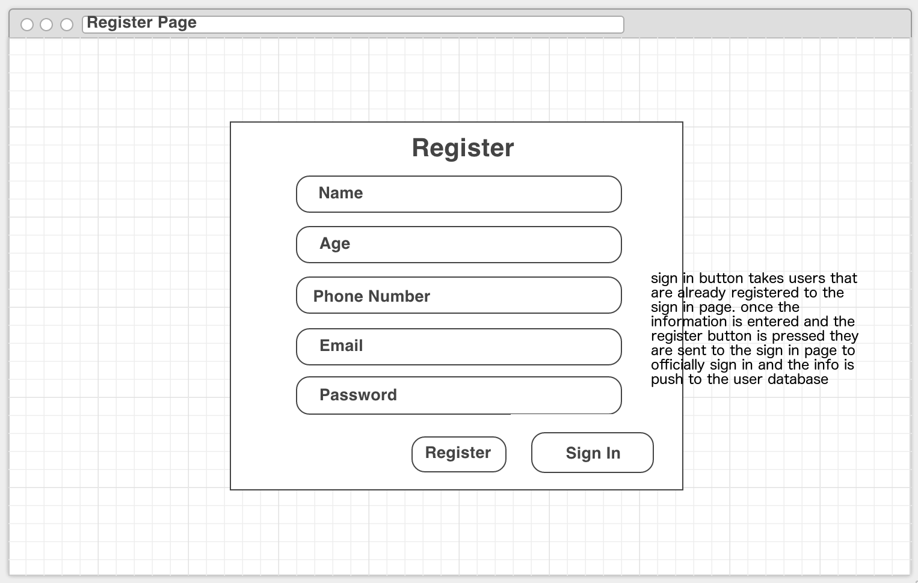

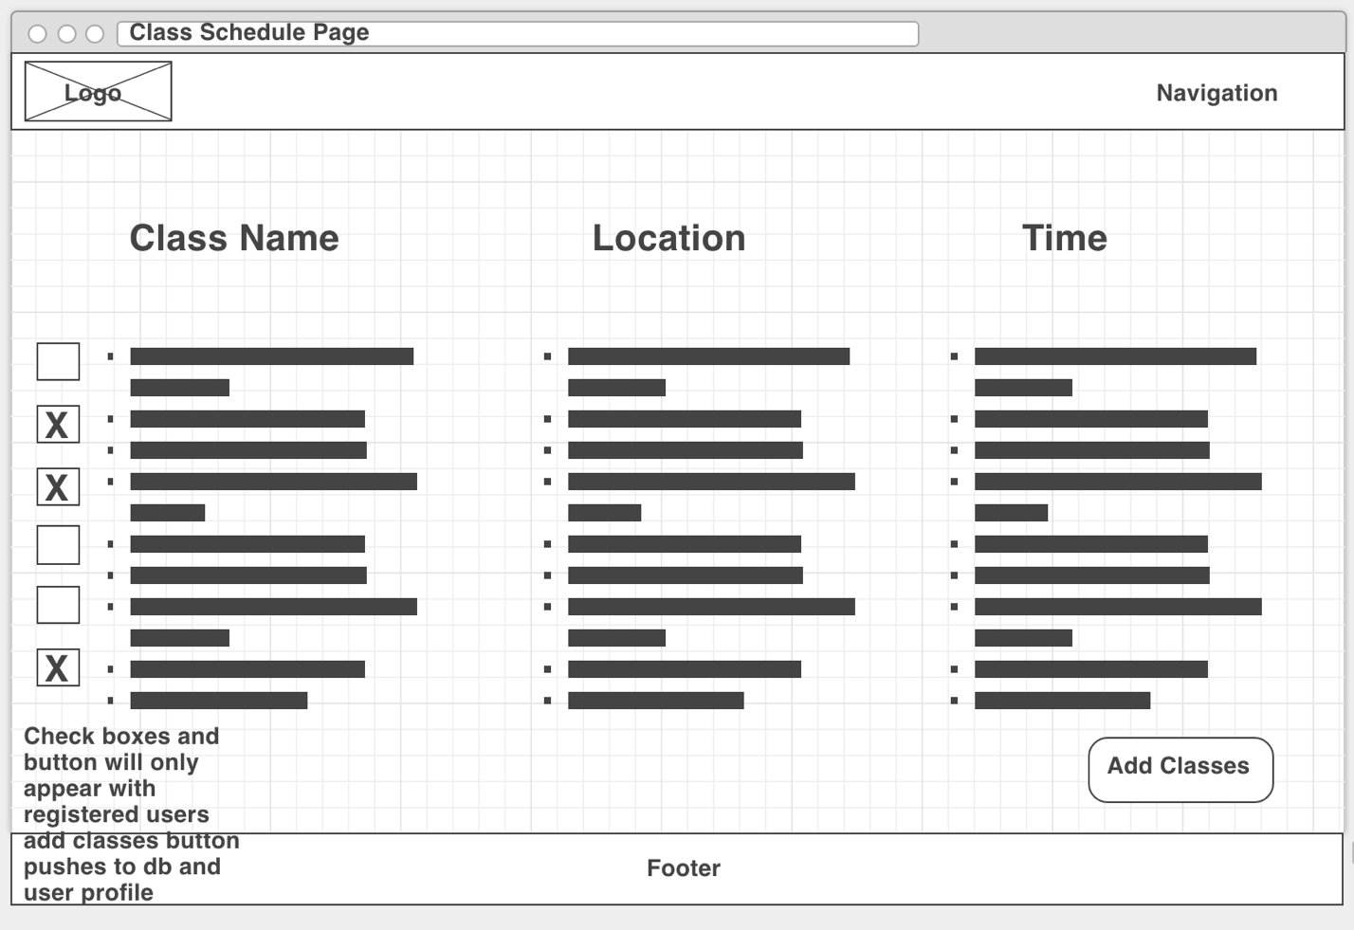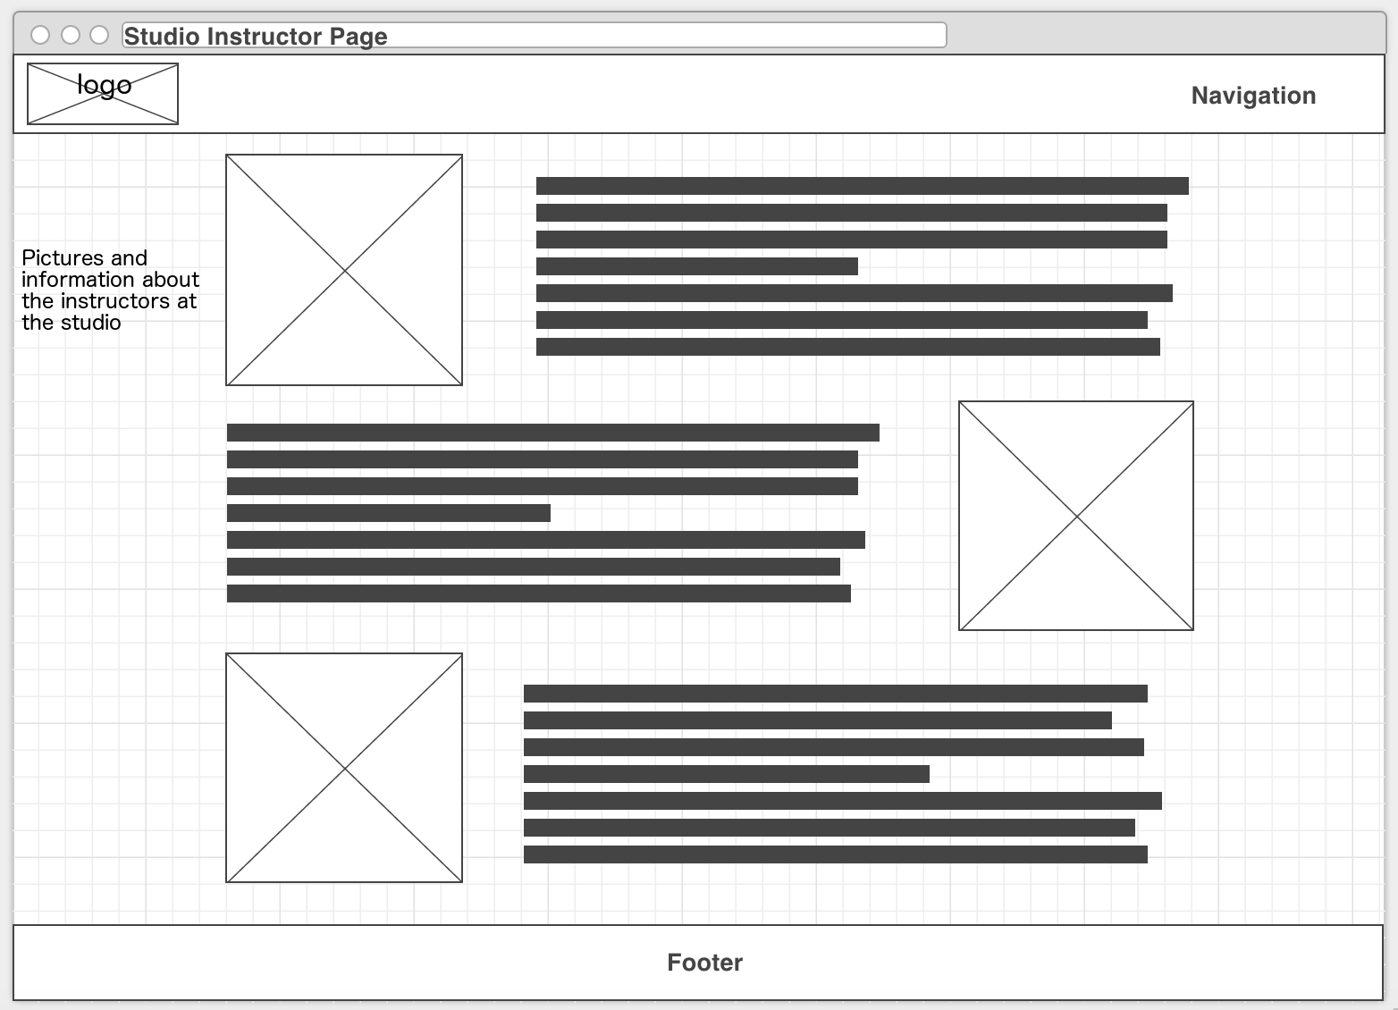

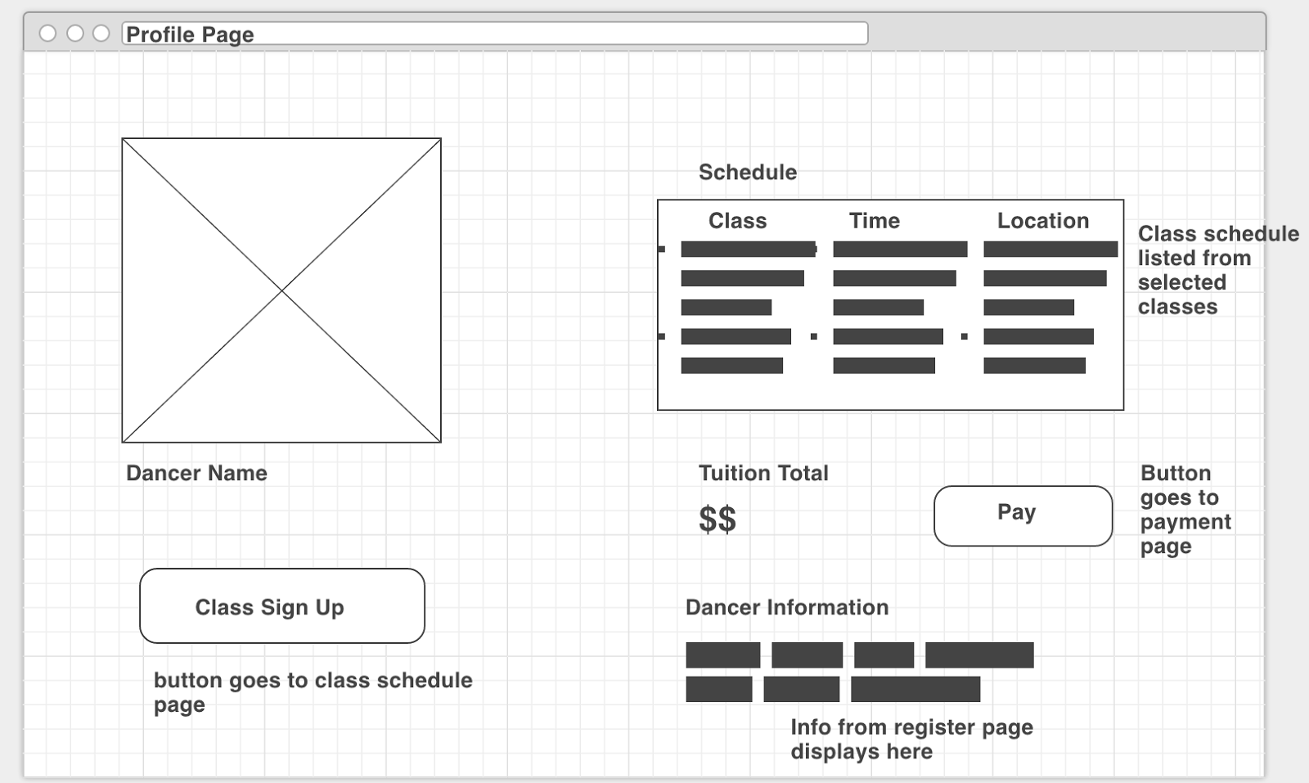

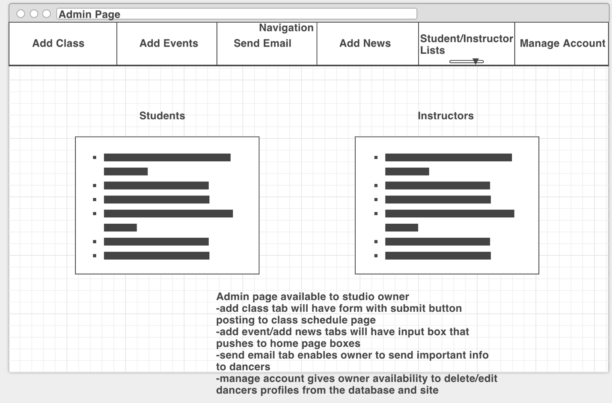

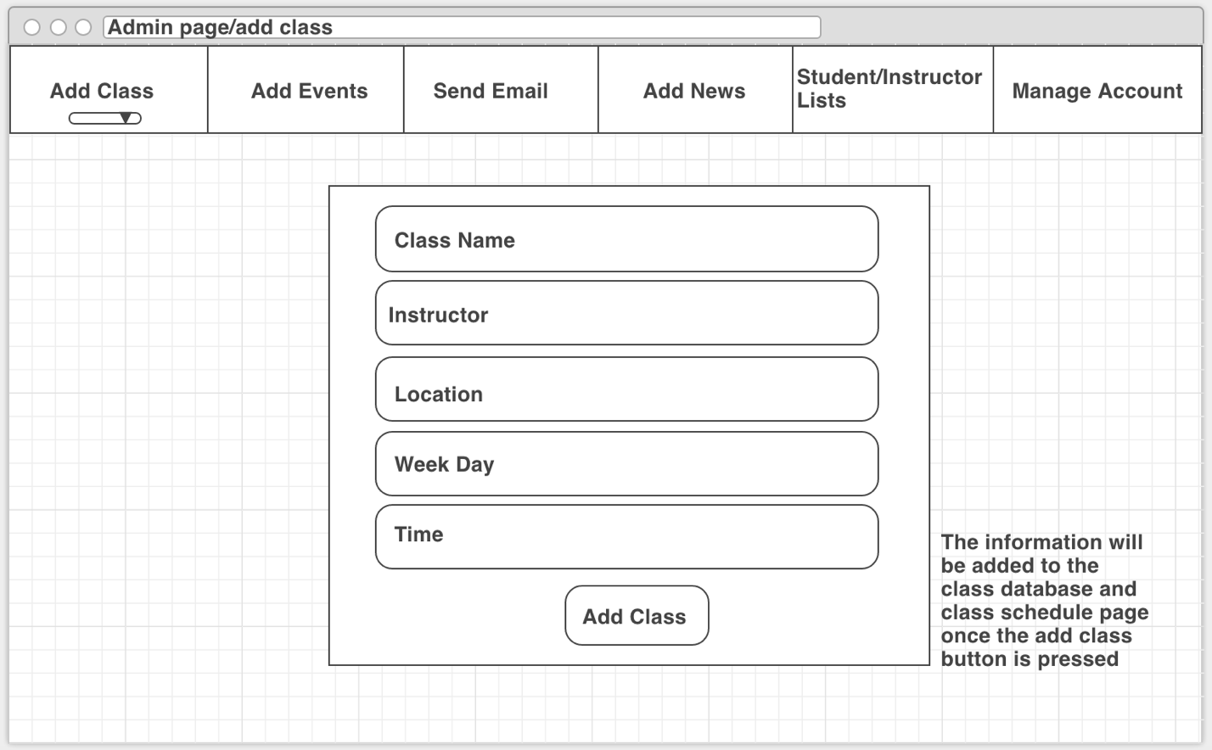

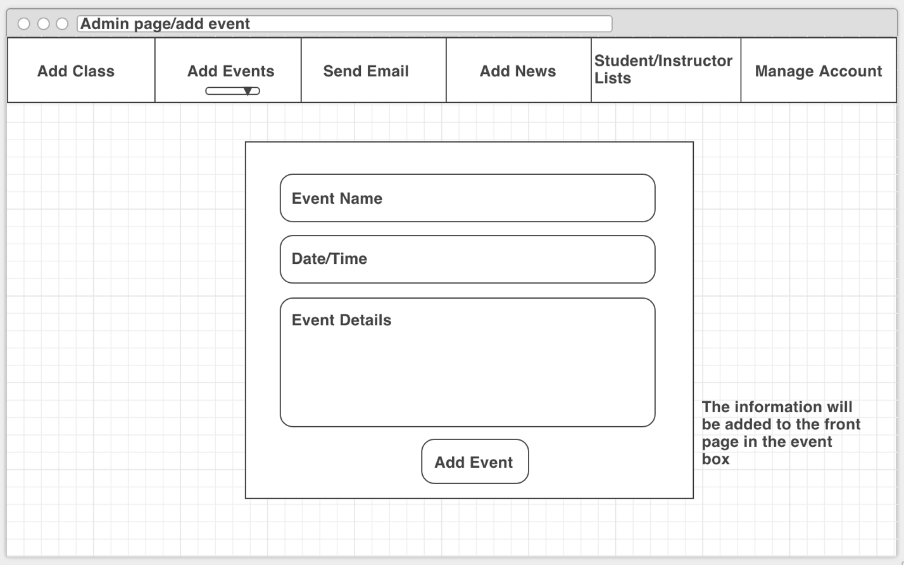

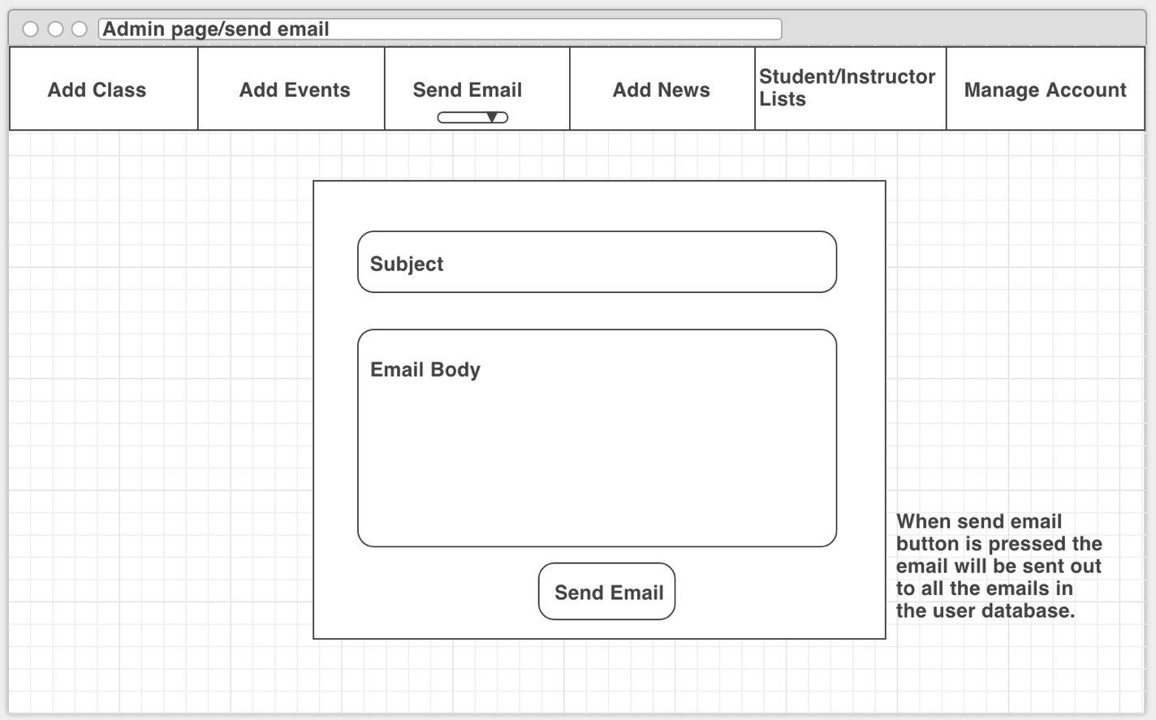

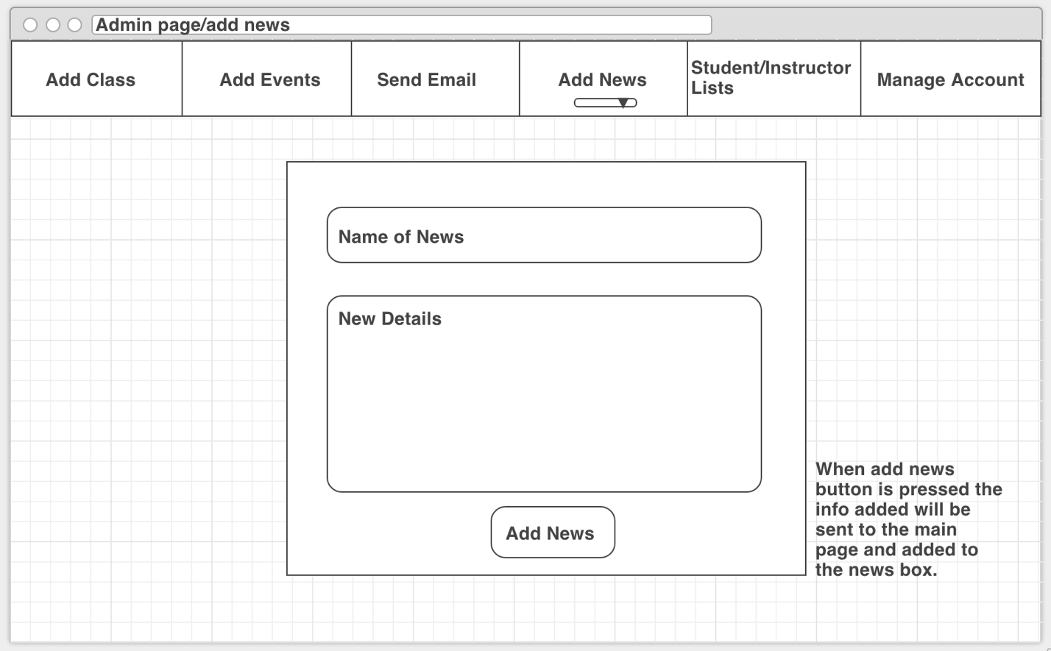

Trello Board

